OS - Permissions Programs
Tasks-
- Give Read and Write only to the owner

Owner = 6 read (4) + write (2)
Group = 0nothing (no permission)
Others = 0nothing (no permission)

- Give Read and Write to the owner and group

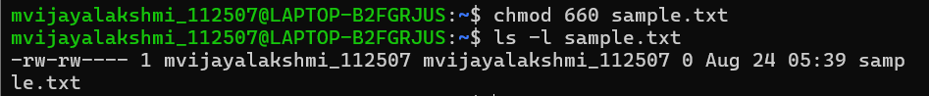

Owner = 6 read (4) + write (2)
Group = 6 read (4) + write (2)
Others = 0 nothing (no permission)

- Only owner can read and write

Owner = 6 read (4) + write (2)
Group = 0nothing (no permission)
Others = 0nothing (no permission)

- Owner read/write, everyone else read-only

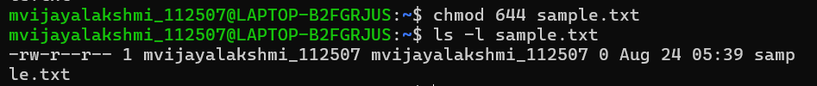

Owner = 6 read (4) + write (2)
Group = 4 read (4)
Others = 4 read (4)

- Owner can do everything, others can only read and execute

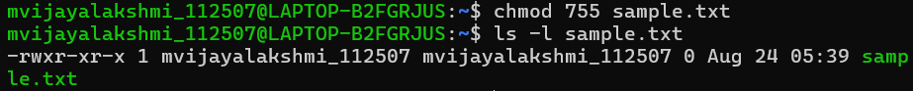

Owner = 7 read (4) + write (2) + execute (1)
Group = 5 read (4) + execute (1)
Others = 5 read (4) + execute (1)

- Owner and group can read/write



Owner = 6 read (4) + write (2)
Group = 6 read (4) + write (2)
Others = 0 nothing (no permission)

- Only owner can execute

Owner = 7 read (4) + write (2) + execute (1)
Group = 0nothing (no permission)
Others = 0nothing (no permission)

Fill in the permission numbers for the following:

8) Owner: read + write; Group: nothing; Others: nothing → 600
9) Owner: read + write; Group: read; Others: read → 644
10) Owner: read + write + execute; Group: read + execute; Others: read + execute → 755
11) Owner: read + write; Group: read + write; Others: nothing → 660
12) Everyone: read only → 444

